Conceptual Design Document – EVA Chat Teams Collaboration Feature
Real-Time and Asynchronous Multi-User Sessions with Governance Controls
Prepared by: AICOE Product Design Team
Version: 1.2
Date: May 8, 2025
1. Objective
Enable EVA Chat to support multi-user collaboration on AI conversations through session sharing, with robust controls for roles, auditing, privacy, and traceability. This will improve team-based work, reduce duplication, and support more accountable usage of generative AI tools.
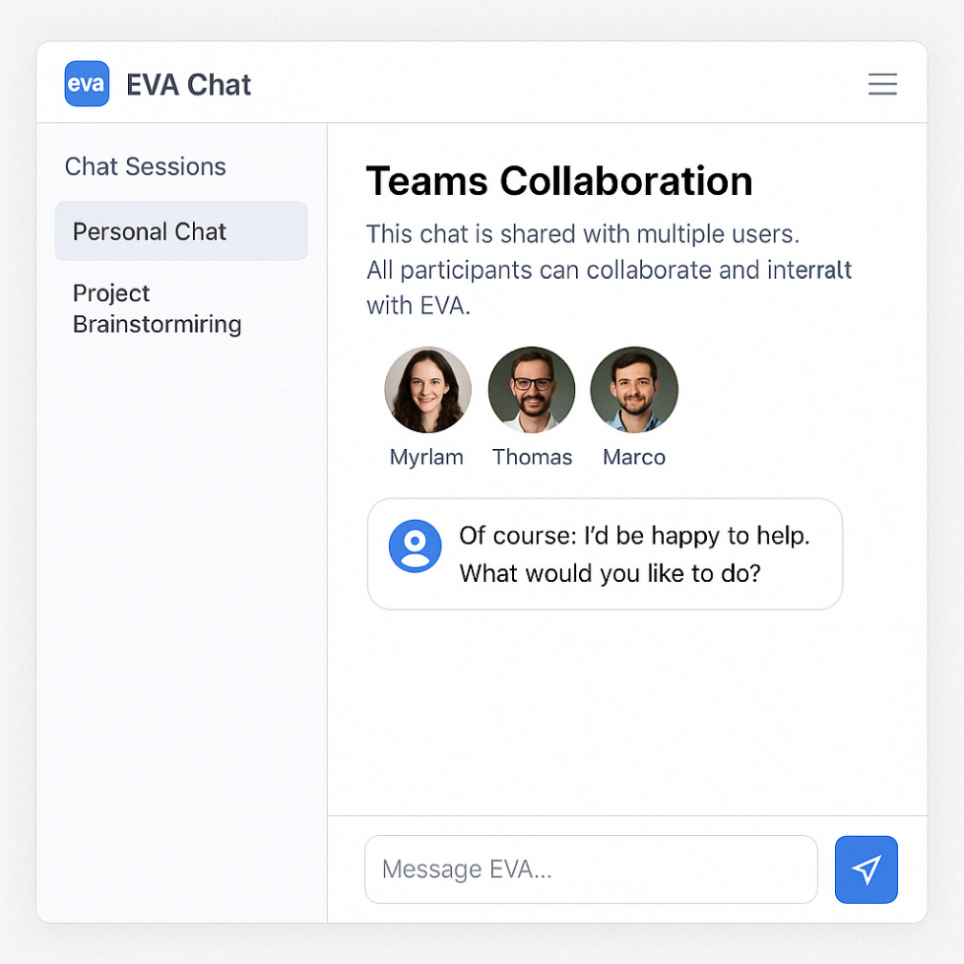

2. Use Cases
- A manager initiates a session and invites their team to co-refine a prompt.
- A service team collaborates on a client-facing response within a shared workspace.
- A reviewer joins a conversation post-interaction to validate the AI-generated draft.
- A CSAT analyst or trust reviewer leaves structured evaluation feedback within the shared session.
- A business owner assigns validator access to verify policy compliance or Protected B usage conditions.

3. Feature Scope
3.1 Session Sharing
- Each chat session has a SessionID and an owner.
- Users can invite others to collaborate using email, group alias, or employee ID.
- Sessions are shared via backend API calls or UI invite modal.
3.2 Roles and Permissions
- Owner: full control, can remove others, edit prompt, archive session.
- Editor: can co-edit prompt and add messages.
- Observer: read-only, can comment (optional).
- Validator: governance/QA role with visibility on flagged content.
- Role metadata includes: SessionRole, AssignedBy, AssignedAt, ExpiresAt.
3.3 UI/UX Design
- Presence indicators for online participants.
- Change log panel to show message authorship, timestamps, and role badges.
- Toggle between "Solo Mode" and "Shared Session" in top nav.
- Option to show/hide internal notes or reviewer comments.
3.4 Notifications
- Notifications sent when a session is shared, modified, commented, or closed.
- Alerts triggered if access is removed due to RBAC policy or expiration.
- Optional digest mode for asynchronous session activity summaries.
3.5 Session Context and Metadata
- ChatSessionParticipants table tracks:
  - SessionID, UserID, Role, JoinTime, LeaveTime
  - AuditTrailID, PromptVersion, ModelUsed, CallerAppID, EndpointID
  - ClearedToViewProtectedB, TrustScoringEnabled, EvaluatorConfidence

4. Backend Architecture
- RESTful APIs:
  - GET /sessions/{id} – retrieves session context, participants, role info
  - POST /sessions/{id}/invite – sends invites and sets role metadata
  - PATCH /sessions/{id}/role – updates a user’s role or session expiry
  - DELETE /sessions/{id}/participants/{userid} – revokes access
- Role resolution derived from IAM (GC or departmental IDP) + local session overrides.
- Shared sessions stored in encrypted state with RBAC evaluation per request.
- All messages and events are versioned and mapped to schema + audit trail IDs.

5. Governance and Security
- Full audit logging: audit_trail_id for all messages, edits, invitations, revocations.
- Sessions default to the most restrictive classification among users and referenced files.
- Protected B content access validation enforced via ClearedToViewProtectedB metadata.
- All changes tracked in immutable logs with version history and change reason codes.
- CSAT and QA reviewers can tag and export feedback to MTP via /trust/export/session/{id}.
- All session-linked activities are eligible for trust scoring, quota tracking, and cost recovery attribution.

6. Optional Enhancements
- Session Forking: Clone a session into a private or child workspace.
- System Prompt Override: Allow owner to inject structured context or task type.
- Governance Labels: Tag sessions as "Policy Review", "Client Draft", etc.
- Search and Discoverability: Session search filters by date, creator, tag, or endpoint.
- Inline Commenting: Non-destructive reviewer comments anchored to specific messages.

7. Key Mechanics
- Shared sessions are always time-bound and scoped to participant roles.
- Trust scoring flags and QA metadata can be edited only by validators.
- Session context (prompt, model, documents) is frozen on fork to preserve decision traceability.
- Permissions are evaluated per action (read, write, export, tag).
- Expiry and revocation automatically update active session participants via notification.

8. Epics and Features
- EPIC 1: Session Sharing Framework
  - Feature: Invite participant
  - Feature: Revoke or modify access
  - Feature: Role-based controls with RBAC
- EPIC 2: Session Collaboration UX
  - Feature: Shared interface with presence indicators
  - Feature: Role-based message attribution and filtering
  - Feature: Change log and session timeline view
- EPIC 3: Trust and Governance Extensions
  - Feature: Validator feedback overlay
  - Feature: Audit log and schema version traceability
  - Feature: Trust export endpoint to MTP
- EPIC 4: Notifications and Alerts
  - Feature: Invite, join, leave notifications
  - Feature: Access expiry and RBAC-triggered alerts
  - Feature: Daily/weekly digest for async workflows
- EPIC 5: Search, Discoverability, and Forking
  - Feature: Session search by tag, status, role
  - Feature: Fork session and relink lineage
  - Feature: Metadata tagging and governance labels

9. Deliverables
- EVA Chat frontend updates for shared session creation and role control
- Backend APIs for session sharing, access validation, and audit trail extension
- RBAC integration for dynamic role-based enforcement
- Metadata and trust scoring schema extensions
- Reviewer UX features (QA dashboards, trust tag exports)
- Documentation and onboarding guidance for collaborative use cases

End of Document

EVA Chat – Teams Collaboration Feature
Allow users to share persistent EVA Chat sessions with colleagues, enabling real-time or asynchronous collaboration on the same AI-assisted conversation.

Key Mechanics

Session Ownership:
Every chat session is still owned by the creator (session owner).

User Sharing:
- The owner can add one or more EVA Chat users (via internal user IDs or email) to a session.

Access Rules:
- A session is visible and accessible if the logged-in user is either:
  - The owner, or
  - An invited participant

Interaction & Visibility:
- All users in the session can view past exchanges, submit new prompts, and see shared responses in real-time.
  - Users cannot delete sessions they don’t own.
  - Optional: Add a small audit trail (e.g., “Marco submitted this prompt”) for context.

Session Refresh:
- Invited users see the shared session after refreshing or reloading their session list.

Permissions & Security

- Only the owner can:
  - Invite or remove participants
  - Rename or delete the session

- All participants can:
  - Read/write within the session
  - Tag others in a message (optional enhancement)
  - Bookmark or export content (if enabled)

- RBAC Consideration:
This can integrate naturally with EVA’s Role-Based Access Control. If a user loses access to the system or changes teams, access to shared sessions should be reviewed or revoked automatically.

Bonus Features to Consider

- Notification System: Let participants opt into updates when a new message is posted.
- Collaborative Labels or Threads: Tag parts of the discussion for follow-up or flag for validation.
- Comment Mode vs. Chat Mode: For large teams, introduce an “observer” role that can leave comments but not drive the chat.



EPIC
: Teams Collaboration in EVA Chat

Title: Enable multi-user collaboration in EVA Chat sessions
Description:
Introduce a feature that allows users to share persistent chat sessions with other EVA Chat users. Collaborators can access the shared conversation, view AI responses, and contribute to the session in real time. The session owner retains full control over permissions and participants.

Feature 1: Share a Chat Session
User Story 1.1
Title: Allow chat session owner to share a session with other EVA users
Description:
As a session owner, I want to invite other EVA users to my session so they can collaborate with me.
Acceptance Criteria:

- Owner can invite users via email or user ID
- Only valid users can be added
- Invitees see shared session upon refresh
- Shared sessions marked in UI

User Story 1.2
Title: Show shared chat sessions to invited users
Description:
As an invited user, I want to see all sessions I’ve been added to so I can collaborate with others.
Acceptance Criteria:

- Shared sessions appear in session list
- UI distinguishes between personal and shared sessions
- Invitees can access full history and contribute

Feature 2: Role-Based Permissions
User Story 2.1
Title: Session owner can manage participant access
Description:
As a session owner, I want to control who has access to my chat session to maintain privacy and control.
Acceptance Criteria:

- Only owner can invite or remove users
- Owner cannot be removed by others
- Owner can rename or delete session
- Invitees cannot delete the session

Feature 3: Real-Time Collaboration
User Story 3.1
Title: Show real-time updates in shared chat sessions
Description:
As a participant, I want to see when others post prompts or responses in real time so we stay synchronized.
Acceptance Criteria:

- Messages appear instantly for all users
- Usernames or avatars shown next to each input
- Timestamp and message attribution tracked

Feature 4: Participant Visibility & Notifications
User Story 4.1
Title: Display list of session participants
Description:
As a user in a shared session, I want to see who else is collaborating with me.
Acceptance Criteria:

- Participant list shown at top of chat
- Hover shows full name and department

User Story 4.2
Title: Notify users when they’re added to a shared session
Description:
As a user, I want to be notified when I’m invited to a session so I can join promptly.
Acceptance Criteria:

- Notification banner or email
- Session appears with “new” tag in list

Perfect. Here’s the data model and backend logic to support Teams Collaboration in EVA Chat.

Data Model Enhancements
1.
ChatSession Table
Add or update fields:

- session_id (UUID, PK)
- owner_user_id (string)
- title (string)
- created_at (datetime)
- last_modified (datetime)

2.
ChatSessionParticipants Table

(New)

This is the core of the Teams feature.
Field Name | Type | Notes
session_id | UUID | FK to ChatSession
user_id | string | FK to EVA users
role | string | e.g. “owner”, “participant”
added_by | string | user_id of inviter
added_at | datetime | timestamp

Permissions Logic

Session Visibility:

- On login or session list refresh, query all sessions where user_id = current_user_id from ChatSessionParticipants.
- Load session metadata (title, owner, timestamps).

Message Access:

- Messages linked by session_id only retrieved if the requesting user is in ChatSessionParticipants.

Role Enforcement:

- Only role = "owner" can:
  - Add or remove users
  - Rename or delete session

Backend APIs (Examples)
GET /sessions
Returns all sessions for current user (owned + shared).

POST /sessions/:id/invite

Payload: { user_ids: [“abc123”, “xyz456”] }
Permissions: Only owner can call
Effect: Adds users to ChatSessionParticipants

DELETE /sessions/:id/invite/:user_id

Permissions: Only owner
Effect: Removes user from shared session

Security & Privacy Considerations
1. Access Control

- Leverage existing Role-Based Access Control (RBAC) to enforce session visibility.
- Only users explicitly listed in ChatSessionParticipants can:
  - View chat history
  - Submit prompts
  - Receive AI responses

2. Secure Sharing Actions
- Sharing actions (invites/removals) require authentication and role verification.
- Audit every invite, removal, and permission change with metadata: who, when, from where (IP/session).

3. Data Encryption

- Chat data is encrypted at rest and in transit (HTTPS).
- All shared sessions must follow the same Protected B data classification rules as personal sessions.

4. Logging and Auditing
- Maintain a full audit trail:
  - Shared session creation
  - Invitee list changes
  - User prompts and AI responses with timestamps and user attribution

- Logs should be immutable and regularly backed up

5. Session Expiry & Revocation

- Owners can revoke access at any time.
- Optional: Add auto-expiry for shared sessions (e.g., 90 days of inactivity).
- If a user’s account is deactivated or removed from a role, their access to shared sessions is automatically revoked.

6. Notification of Access

- Participants are notified (e.g., via UI banner or email) when:
  - They are added to a session
  - A session is renamed or deleted
  - A message is tagged for review or flagged

7. Privacy Safeguards

- No participant can download the full chat history unless the owner grants explicit export permission.
- Optional: Redact or mask sensitive content based on classification tagging (automated or manual).

8. Human-in-the-Loop Reminder

- Insert a clear system message in shared sessions:
“All participants are accountable for verifying the accuracy and completeness of AI-generated content before use. Do not share protected or personal data unless authorized.”

